REQUEST FOR PROPOSALS

TO

UNDERTAKE FEASIBILTY STUDIES AND DEVELOPMENT OF LIVESTOCK PROJECTS AT MASINGA, KIAMBERE, EMALI AND TANA DELTA IRRIGATION PROJECTS (TDIP).

TANA AND ATHI RIVERS DEVELOPMENT AUTHORITY

Table of content

1. PRESENTATION of ELLIPSE PROJECTS Erreur ! Signet non défini.
2. Proposed organization for the project 3
3. Presentation of potential project partners 5
3.1 Animal food value chain Erreur ! Signet non défini.
3.2 Prophylaxis Erreur ! Signet non défini.
3.3 Meat value chain Erreur ! Signet non défini.
3.4 Dairy value chain Erreur ! Signet non défini.
3.5 Equipment Erreur ! Signet non défini.
4. References, Ellipse, Group and Partners Erreur ! Signet non défini.
5. Methodology Overview 6
5.1 Phase 1 - Assessment of current situation 6
5.2 Phase 2 – Collecting and Understanding Requirements 8
5.3 Phase 3 - Technology and products assessment / Market evaluation 8
5.4 Phase 4 - Technical definition of project 9
5.5 Phase 5 - Analysis of Environmental Impact 9
6. Work Plan 11
6.1 Project Schedule 11
7. Proposed Staff Erreur ! Signet non défini.
8. Curriculum Vitae Erreur ! Signet non défini.
9. TIME SCHEDULE FOR PROFESSIONAL PERSONNEL Erreur ! Signet non défini.
10. ACTIVITY (WORK) SCHEDULE 12
11. SITES VISIT 13
11.1 Masinga 13
11.2 Kiambere 15
11.3 Emali 17
12. Financial offer Erreur ! Signet non défini.
13. BOQ Erreur ! Signet non défini.

-roposed organization for the project
Ellipse projects plans to act as the main contractor and coordinator to conduct the consultancy services phase subject to the present tender. Ellipse will rely on its partners to complement its skills and bring in the specific expertise in some particular domains.
For the execution of the consultancy services, Ellipse will assign consultants and senior consultants from its own staff, including a principal consultant in charge of Project Direction and rely on the staff of its subsidiary in Kenya for part of the local consultancy services and support.
Ellipse will include the support of subject matter experts from the French association ADEPTA, or independent consultants.
Created in 1977, ADEPTA is part of public initiative measures from the French Ministry of Agriculture and Fisheries to support French external trade.
Its role is to accompany the international development of equipment manufacturers, suppliers of farming equipment and supplies, experts and engineering and design departments in the agriculture and agro-food industry.
ADEPTA members are French companies committed to develop their export business and hence are willing to participate in such projects that they consider as an opportunity to grow their business in the region.
Ellipse will liaise with these manufacturers and suppliers of the agro-food industry sector, either directly, or through the ADEPTA association.
The following diagram shows the planned team organization for the project and the relationships with the different stakeholders.
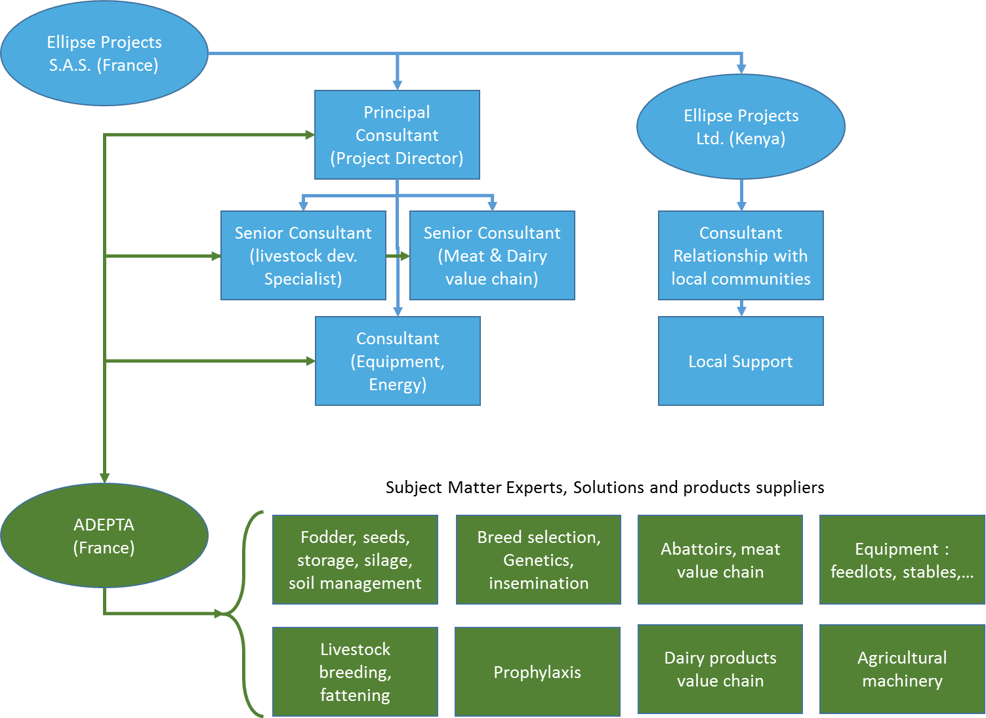

The core team comprises 5 persons:
- A principal consultant acting as Project Director
- Two senior consultants in charge of the key processes
- One consultant in charge of the selection of the equipment, relying on specialists for each subject matter (like civil works, buildings, silos, energy, etc…)
- One consultant in charge of the relationship with local communities.
The core team relies on the back office resources of Ellipse in France and in Kenya and on the support provided by Ellipse Kenya for the relationships with the Kenyan regulatory authorities and institutes of standards.

Presentation of potential project partners

The following companies, either member of ADEPTA or French companies, may be selected to participate to the project.

Methodology Overview

The methodology adopted within the framework of the assignment will comprise the following phases:

Phase 1 - Assessment of current situation
An assessment of the existing situation in the 4 areas of project implementation
This phase will mainly consist in understanding the current context of each area in terms of:
Geographical data
- topographic data : GPS coordinates, altitude,
- type of land (plain, mountains)
- weather conditions, particularly temperature, rainfall and hygrometric conditions (rain season)
- risks of drought, of flooding
Administrative, social, local and global economic data
- population density (number of villages, location within territory, number of people) in the vicinity, organization,
- revenue sources and income level of local population
- land owner (State, TARDA ?)
- understand how TARDA is connected to the field / to the local communities (local offices, local representative)
- territories of local population
Technical data
- existing sources of power (grid, water dam, none)
- existing sources of water
- underlying communications network and connection to the cities : roads, train
Existing livestock development environment
- pastoralist communities structures and activities around
- other existing infrastructures
- identify common diseases that cattle may suffer from
- potential interaction between livestock and wildlife (wildlife migration corridors)

Areas of Project implementation
The maps below highlights the counties and places where the land lots under consideration for the project are located.

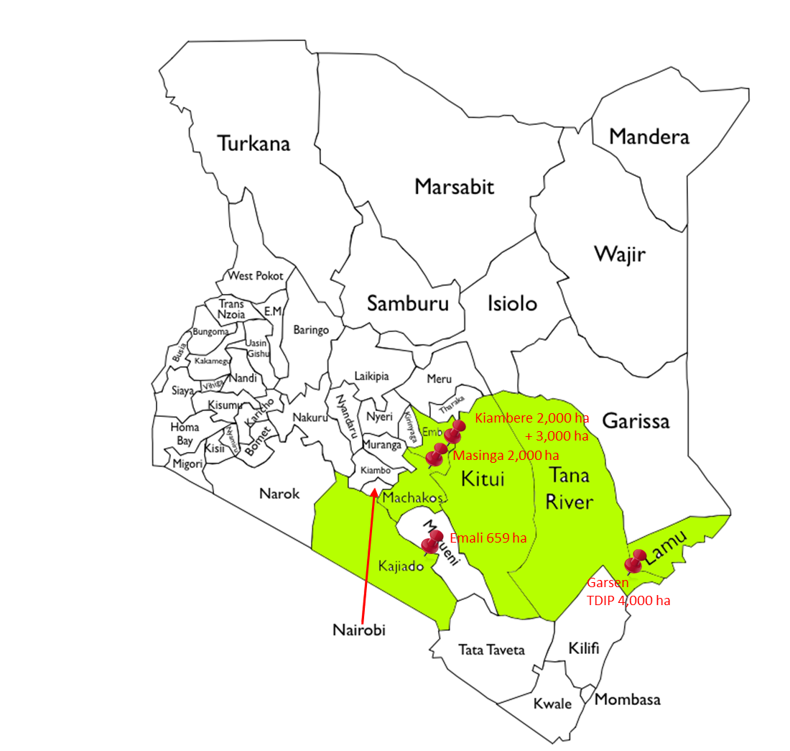

Phase 2 – Collecting and Understanding Requirements
This phase will consist in the following tasks :
- gathering the requirements and the expectations from TARDA
- interviews of local communities in order that those are involved upfront and adhere to the project
- potential markets opportunities analysis (local, in-land and the sub-region) will be another input at this step,
- analysis of the regulatory environment
- understanding the health and safety standards requirements
- security requirements (equipment and staff)
The outputs of this phase will include sizing information for each project implementation area, in terms of herd head count, dairy and meat production facilities requirements.

Phase 3 - Technology and products assessment / Market evaluation
On the basis of the previous step outputs, ELLIPSE will make a comprehensive assessment of the technologies, products and solutions offered by the market to find out the best suited solutions and products that comply with the requirements, focusing on:

- Sizing optimized for the projects
- Long lasting, durable solutions
- Value for money
- Total cost of ownership

The following gives a sneak preview of potential products and suppliers which may be involved / associated to the consultancy study.

Intermediary Report
At the end of phase 3, a report will be produced that actually concludes phases 2 and 3.

The report will summarize our understanding of the requirements and specify which technologies and or solutions we intend to implement in order to achieve them.

This report will be reviewed and approved by the customer within a 2 weeks timeframe before phase 4 and subsequent phases can start. This step is important because it will ensure that our analysis is the right one, in line with Customer expectations, and that the technologies / solutions proposed are acceptable by TARDA.

Phase 4 - Technical definition of project
Based upon the previous phases outputs and results and after validation of the intermediary report, this step will specify the infrastructures required for each area of the project implementation, as regards:
- Fodder production and storage facilities (silos)
- Irrigation requirements
- Develop a soil management plan, including recommendations for soil fertilization
- Selection of cattle breeds
- Livestock breeding process, involving pastoralist communities and including feeding, fattening process
- Definition of prophylactic measures to be put in place
- Development and implementation of a traceability process and tools
- Implementation of abattoirs and the cold chain to ensure meat transportation complies with agreed quality and safety standards
- Definition of buildings, offices, sheds required
- Definition of agro machinery required (tractors, trucks, fork lifts, etc….)
- Environmental integration of the project, including a study to consider usage of by-products to produce heat and / or electricity (Combined Heat & Power)
- Identify the potential hazards in each area of the project and prepare mitigation strategies
- Specify power requirements (either from the grid or solar or genset or self-generated by way of biogas)
- Prepare training programs for TARDA staff and local communities education on animal health and prophylaxis
- How to foster the development of communities connection to the markets

This phase may end up suggesting several technical (and financial) options, that will require customer approval before implementation.

Phase 5 - Analysis of Environmental Impact
This phase will be interactive with the previous one. Each technical choice / option considered in the previous phase will require an adjustment of the environmental impact analysis. The environmental analysis may also require amendments / changes in the design.

These steps of the process are represented here in a different way showing the mainstream on the left and the collaterals / transverse domains on the right:

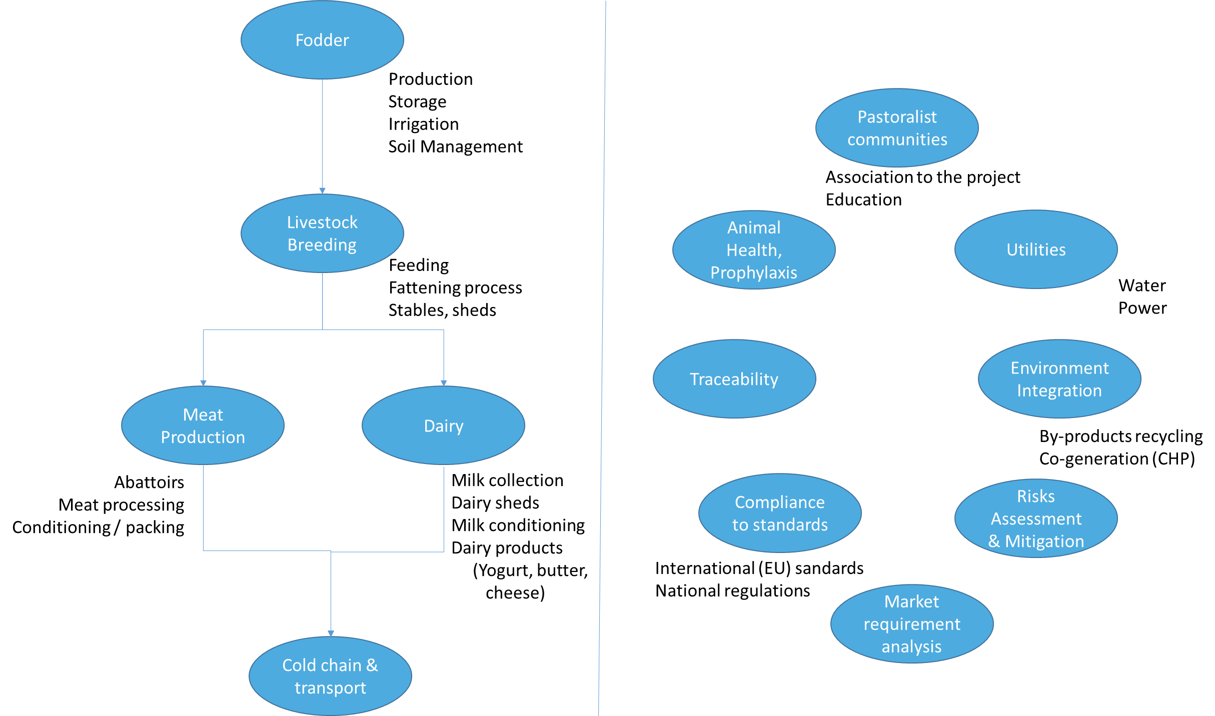

This phase will be highly interactive between ELLIPSE and the different project stakeholders as well as the potential suppliers of each sub-system.

A special emphasis will be put on animal health, prophylaxis, and traceability, with particular care to the way the cattle is managed when it is transferred from the local pastoralist communities to the breeding process.

Work Plan

Project Schedule

The following diagram shows the previously described project phases arranged as a schedule.
The overall assignment is planned to take place in a six month timeframe.

T0 : Confirmation
of FASEP funding
and Downpayment
Intermediary Report
Intermediary Report

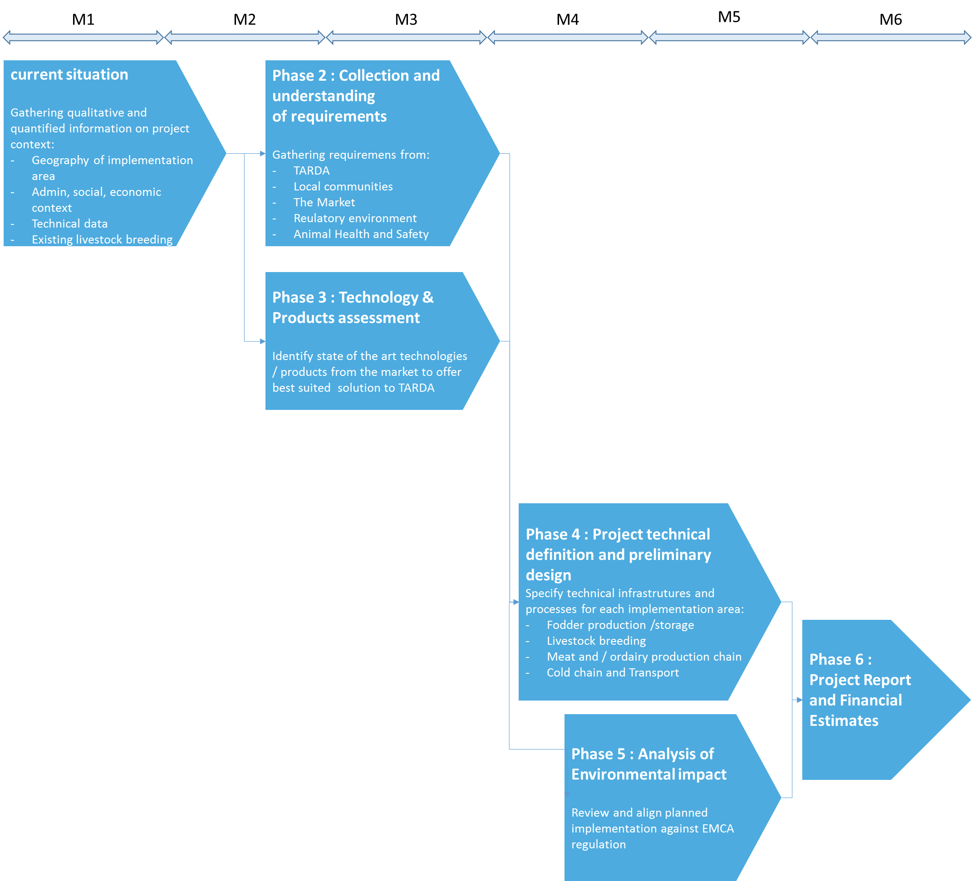
Final Report
Approved by TARDA
Intermediary Report
Intermediary Report

Intermediary Report
Validation by TARDA
Intermediary Report
Intermediary Report

In parallel to the work schedule above, we plan to conduct some sample seeds testing in the field to confirm the best fodder choice for each area of the project implementation.

ACTIVITY (WORK) SCHEDULE

Activity (Work) | 1st,2nd, etc…, are months from the start of assignment)
 | 1st | 2nd | 3rd | 4th | 5th | 6th
Confirmation of FASEP fund allocation to Ellipse and Downpayment = T0
Assessment of current situation

Collection and understanding of requirements

Technology and Products assessment,
Intermediary report

Intermediary report validation by TARDA
Project Technical definition and Preliminary design

Analysis of Environmental Impact

Project Report and Financial estimates
Final Report Validation by TARDA

SITES VISIT

Masinga
14/10/2014
Geographical and technical data:
1) Area: 2000 Ha
2) Type of land: Plain
3) Type of soil: Black cotton
4) Average rainfall is 450 to 550ml
5) Flooding risk none because of spillway
6) Power source: grid
7) Water source: Masinga dam
8) Existing pump house is far from the water. The level of the dam was a lot higher when dam was constructed and has been too low for years.
9) Existing road to site from main highway is worn tarmac that will need recarpetting

Administrative & social aspects
1) Land is owned by Tarda
2) Income level of local population is low main source is charcoal burning, livestock (few goats) and farming
3) There are squatters who according to tarda leave the area whenever they are requested
4) Population density is low because the area is semi arid
5) Interaction with wildlife is minimal

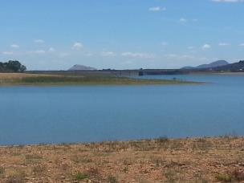 | 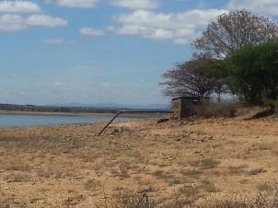
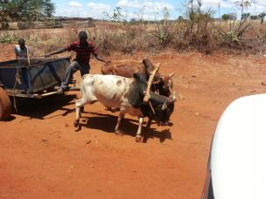 | 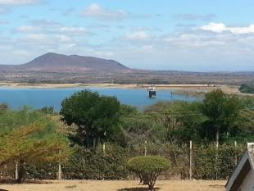
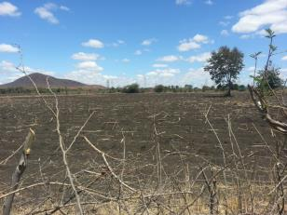 | 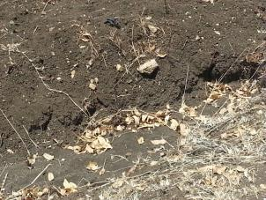
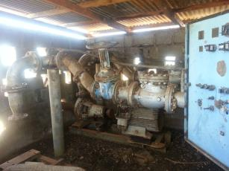 | 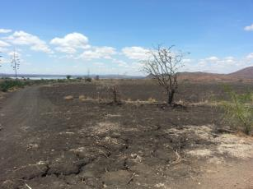

Kiambere
14/10/2014
Geographical and technical data:
1) Area 3000 Ha
a) Type of land: Plain
b) Type of soil: Black cotton
c) Average rainfall is 450 to 550ml
d) A section of the farm has piping network for irrigation
e) Flooding risk: None because of spillway
f) Power source: grid
g) Water source: reservoir filled from Kiambere dam. A 14” pipe runs from the pump house to reservoir.
h) Existing road to site from main highway is worn tarmac that will need re-carpeting
2. 2000 Ha
a) Type of land: Hilly with 30% plain
b) A section about 250 acres has a forest plantation
c) Type of soil: Rocky, Black cotton
d) Average rainfall is 450 to 550ml
e) Flooding risk: None because of spillway
f) Power source: grid
g) Water source: Kiambere dam
h) Existing pump house is far from the water. The level of the dam was a lot higher when dam was constructed.
i) Existing road to site from main highway is worn tarmac that will need re-carpeting

Administrative & social aspects
1) Land is owned by Tarda
2) Income level of local population is low, their main source of income is charcoal burning, livestock (few cows & goats), fishing and farming
3) There are squatters who according to tarda leave the area whenever they are requested
4) Population density is low because the area is semi arid
5) Interaction with wildlife is minimal
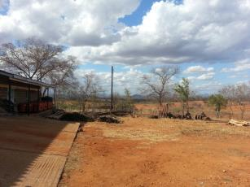 | 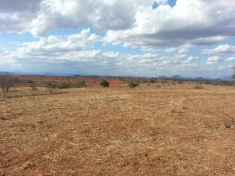
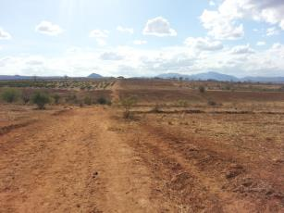 | 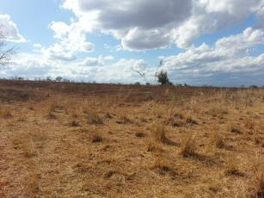
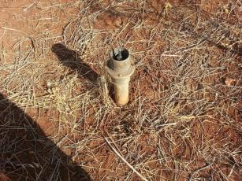 | 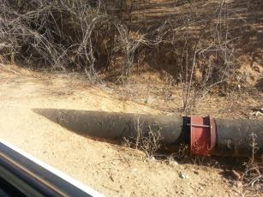
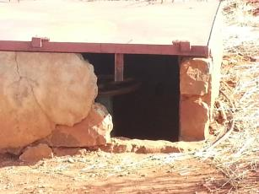 | 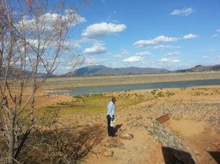

Emali
15/10/2014
Geographical and technical data:
1) Area: 700 Ha
2) Type of land: Plain, 2 sections divided by Mombasa road
3) Type of soil: Redsoil
4) Power source: Grid. There is no power connected to the farm but there grid is available and can be connected
5) Flooding risk: none
6) Water source: Borehole, Kilimanjaro water supply and rainfall
7) Mombasa road passes through the farm

Administrative & social aspects
1) Land is on lease to Tarda
2) Income level of local population is low main source is livestock and farming
3) There are no squatters but Maasai herders bring their livestock to the land for grazing but according to tarda leave the area whenever they are requested
4) Population density is low
5) Interaction with wildlife is high, there were zebras and antelopes present during our visit.
6) There is a market for livestock held every Friday next to the farm.

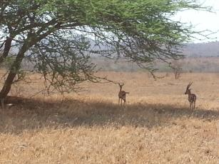 | 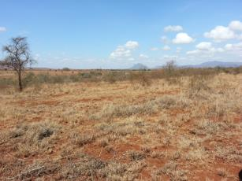
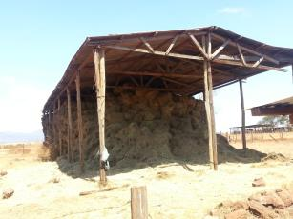 | 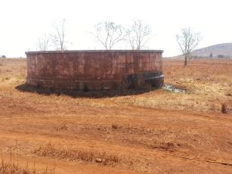
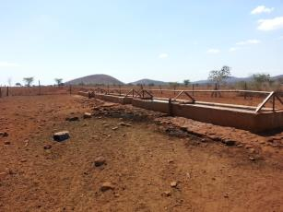 | 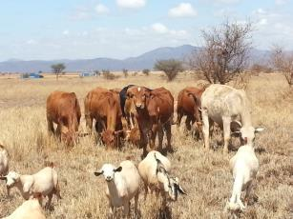
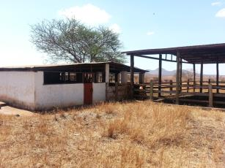 | 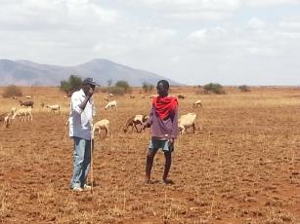

Signed:
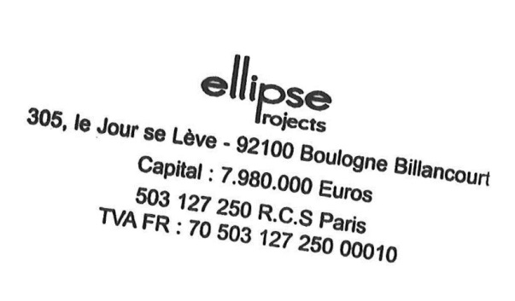
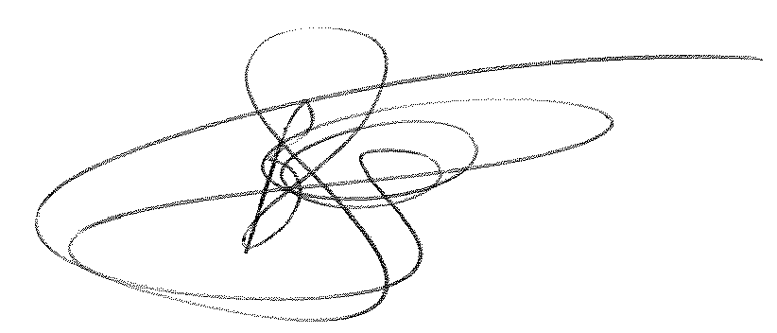

_______________________________

In the capacity of: Vice-President

Name: Mr Bruno Schambacher

Duly authorized to sign the bid for and on behalf of: Ellipse Projects SAS

Dated on the 28th day of October, 2014.

hereabove prices are expressed in Euros and are exclusive of VAT, withholding taxes and all other taxes.

