Methodological approach

For the two shapefiles shared, I am checking the information inside the polygons.
For the point information, I am drawing a polygon for the area I am interpreting and share it as a kml
I am also collecting some polygons of the crop that could be used as training samples

1) Current status of the crop
2) Type of crop (annual/perennial)
3) development of the crop over the years (illustration , some examples)

1) visual review of satellite imageries and land cover maps available:

A. VHR on Google Earth
I am checking the Very High Resolution imageries available on Google Earth (50 cm spatial resolution - I can see if the trees are oil palm or rubber, and make a guessing about jatropha from other type of crops based on the size of the parcels and the aspects of the vegetation)

B. Landsat and Sentinel-2 time series

and other High Resolution Sentinel-2 and Landsat 8 image (10 to 30 meter resolution - I can see change like clear cut in plantations, new crops parcels)

C. NDVI times series from Landsat and Sentinel-2

This takes a few hours per deals once I have all the information. This is what I did so far for the two shapefile. Now that I have it organised, I can easily review more places indeed

2) Try more advanced classification techniques

To get the most of satellite imageries, you need to process the information they contain throught with some classification algorithms. This is not straightforward. But it is feasible, just need some more time for testing. And it helps to have some field information (ideally this could be done/improved after their field visits).

This is done afer step 1 and preferably with field data or extensive knowledge

Shapefile deals: GOPDC and Smart Oil

For the two sites, there is an interest to check on available satellite imageries how much land is currently used for the original crop and how much for the new crop and in both cases when the new crops started

Deal GOPDC – deal number 3771

Crop: GOPDC is into Oil Palm but with plans to add Rubber.
Timing: GOPDC started in 1975. GOPDC was later transferred to SIAT in 1990.
Question: Can we observe a conversion from Oil Palm to Rubber and what is the time of implementation?

Summary of the satellite imageries interpretation: Yes, we can observe a conversion from Oil Palm to Rubber, it is not possible from the imageries available on Google Earth to say the date of implementation. An image of 2015 indicates that some of the rubber trees were implanted between 2015 and 2019. In 2019, we observe clearly patches of rubber trees in different location of the plantation. The majority of the plantation is still covered by Oil Palm.

- Visual interpretation
  - Very High Resolution images (VHR)

We review VHR imageries in Google Earth. There are very few VHR images available. However, on an image from December 2019 shows clearly that two types of trees are cultivated in the deal.

On the left, oil palm is recognizable by the geometry of its crown. On the right, the plantation geometry looks like other examples of rubber plantation. From a visual inspection of the VHR from December 2019, The major crop is oil palm but patches of rubber trees are visible in different areas of the deal. No clear VHR is available for an earlier period of time to say for how long the rubber trees are planted.

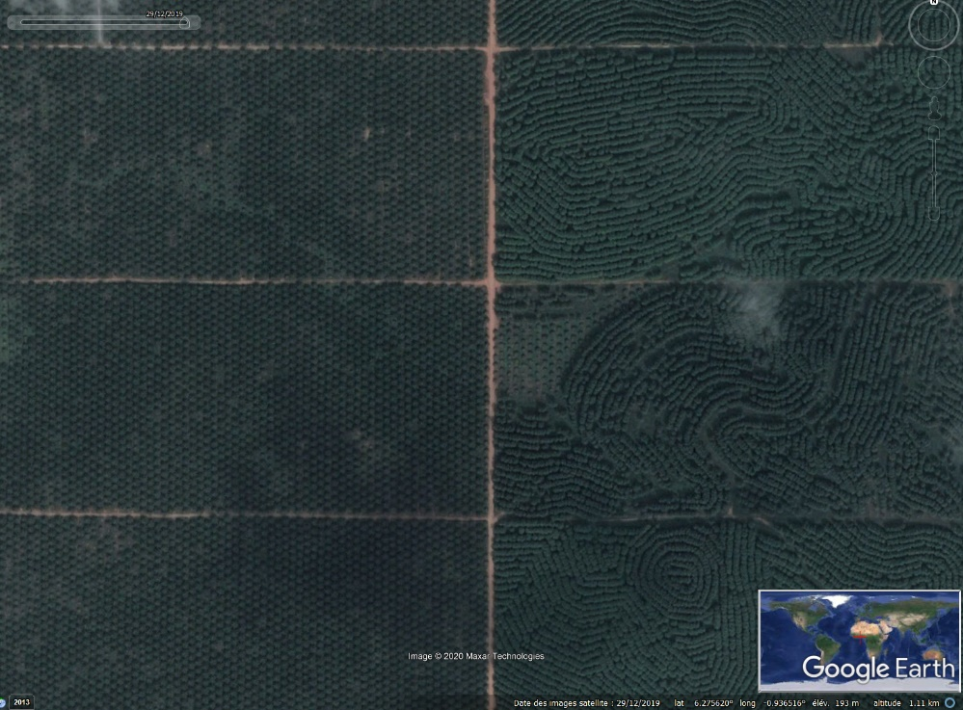
Figure 1 : Zoom in the GOPDC oil palm plantation (oil palm trees visible on the left) where rubber trees are also planted (rubber trees visible on the right)
  - High resolution Landsat and sentinel data
Those imageries don’t present a sufficient spatial resolution (10-30 m) to visually differentiate between oil palm and rubber trees. Advanced classification mapping techniques would need to be used here to complement the analysis.

- Global Forest Change product
We reviewed the existing thematic product GFC available at https://www.globalforestwatch.org/map and showing any tree cover loss in the period 2000-2019. In the case of GOPDC it doesn’t discriminate oil palm from rubber trees. The information we can derive is that the most of area covered by the shapefile communicated for the deal GOPDC has loss its tree cover at a moment between 2000 and 2019. Three quarter is covered by the industrial plantation and the remaining quarter is covered by villages and small scale fields.

Smart Oil – deal Ghana 1322

Crop: Smart Oil is into Jatropha with plans to add food crops.
Timing: Smart Oil started in 2006
Question: Check the extansion of Jatropha and the conversion to food crops. Understand if there is other crops aside the Jatropha.
Have Jatropha plantation increased?
Did the Initial parcel close to the lake changed from Jatropha to something else?

One need to be careful when interpreting as native crops can still be present. New crops can also be native. But the size of the parcel should enable us to distinguish it.

- Check for growing of large scale food crops. Food crops from the company:
Vegetables (green pepper, pepper). maize

Summary: yes large parcels that can be food crops are visible in the deal. Jatropha was present in 2014 in the polygons close to the lake but I am not sure it is still present.

Satellite imageries interpretation:

A first remark is that the deal 1322 - Smart Oil is a good example of how the point localisation is not always very representative of a deal. The point (in red) is falling in the middle of the three polygons associated with the deal.

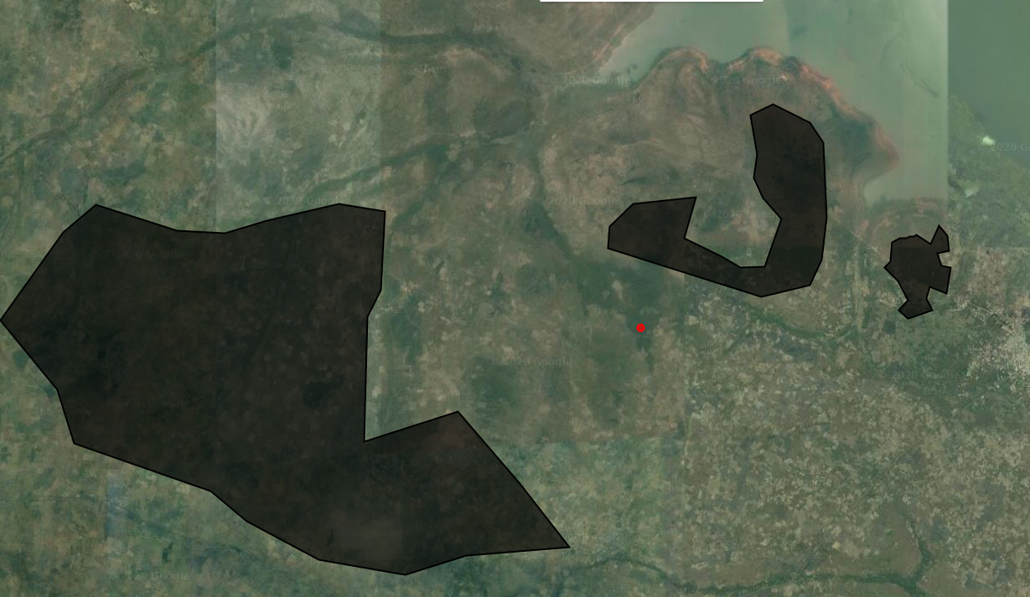

- Visual interpretation
  - Very High Resolution images (VHR)

The collection of VHR on Google Earth is quite poor. However, some VHR from 2014 and 2016 are indicating the presence of large-scale crops that can be Jatropha on the two polygons close to the Volta lake. An image from 2020 covering only a very small portion of the deal tends to show that such large-scale crops are still present in 2020.

The polygon that is more inland shows less industrial development.

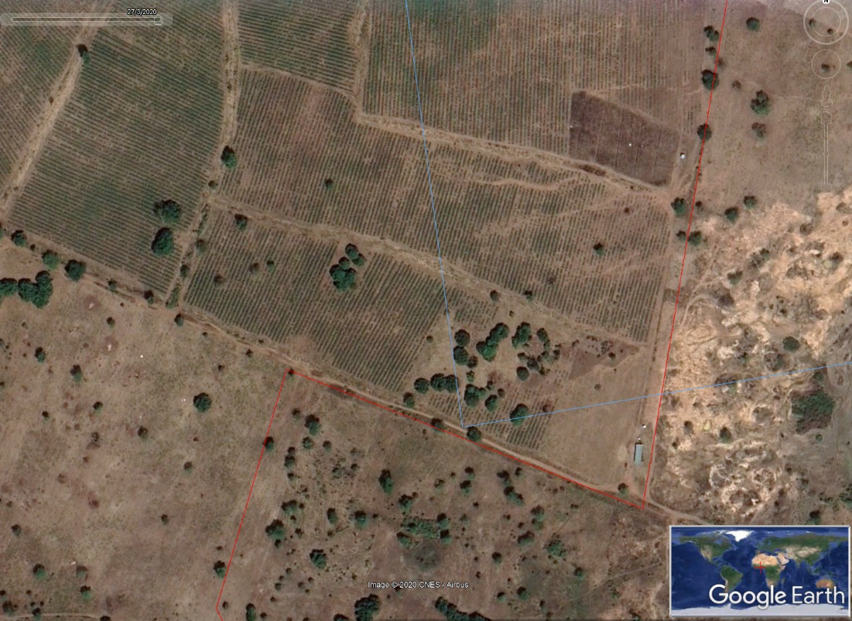

  - High resolution Landsat and sentinel data
Here the Landsat and Sentinel-2 data helps us get more insight into the development of the activities in the deal.

From Landsat (30 meter resolution, available since 1984), we can spot the first signs of implementation in 2012 in the polygons close to the lake. Large-scale agricultural parcels are visible. From Sentinel-2 (10 meter resolution, available since 2016) it seems that activities are increasing in intensity since 2016. In the polygon more inner land, there was always some small scale parcels. Since 2016 the shape of the parcels are changing in the north eastern part (industrialisation?). My hypothesis is that those parcels are not Jatropha but food crops. They are bigger and different than the native crops visible in the surroundings. They represent only a small portion of the polygon.

Again, to differentiate Jatropha from food crop, a finer analysis is needed.

NDVI profiles – temporal interpretation
For Smart Oil, we can also go further. As mentioned, it would help to have field data of where Jatropha is located and at what time to transform this into a map.

Deals shared as points

For the points shared, we know that they are part of an industrial structure. I did a first visual review of the current status of the deal and development over time for the deal with clear infrastructure.

I am sharing a list of kml together with the interpretation so that you can see the part I have been interpreting. You can open the kml in Google Earth.

Deal 1323 – Galten
Crop: Jatropha for biofuels
Timing:
Question: What is the current status? Is it still active?
Summary of the satellite imageries interpretation: The area closed to the point 1323 is not showing clear example of recent plantation of Jatropha. The size of the parcels seems to have decrease between 2015 and 2018. However, more in the East, there are clear evidence of recent implementation of new area with Jatropha.

- Visual interpretation

Around the point shared for the deal 1323, an industrial infrastructure is visible, recognizable from the large parcel size. From the interpretation, I am spotting two different areas, mapped in as two kml (google earth polygons) “Deal1323_Galten_Part1” and “Deal1323_Galten_Part2”. There is in the south east of the point shared for the deal 1323 a place recently cleared and turn in industrial cultivation.

Part1: In 2013, large area of land are cleared. In 2014, linear features are visible in large parcels on a VHR. That pattern is fitting the way Jatropha is cultivated. However, in the next VHR available in 2018, smaller parcels are visible. Those smaller parcels makes me think of food crop. But it is impossible to say whether this is related to food crops cultivated in intercropping with Jatropha or if there is only food crops. I am not spotting the typical linear features of the Jatropha, neither the presence of shrub vegetation. This makes me think that Jatropha was replaced by other food crops, but I am not really sure. Maybe they are old plantations. We would clearly need a field information to confirm this and gain knowledge also for in the satellite imageries interpretation.

Part 2: In part 2, industrial infrastructures are visible as well since 2013. In addition, in recent images (2018 and 2020), it is clear that new area (about 30ha in 2019) have been cleared and a shrub vegetation organised in linear features is planted. My hypothesis is that those are new plantations of Jatropha.

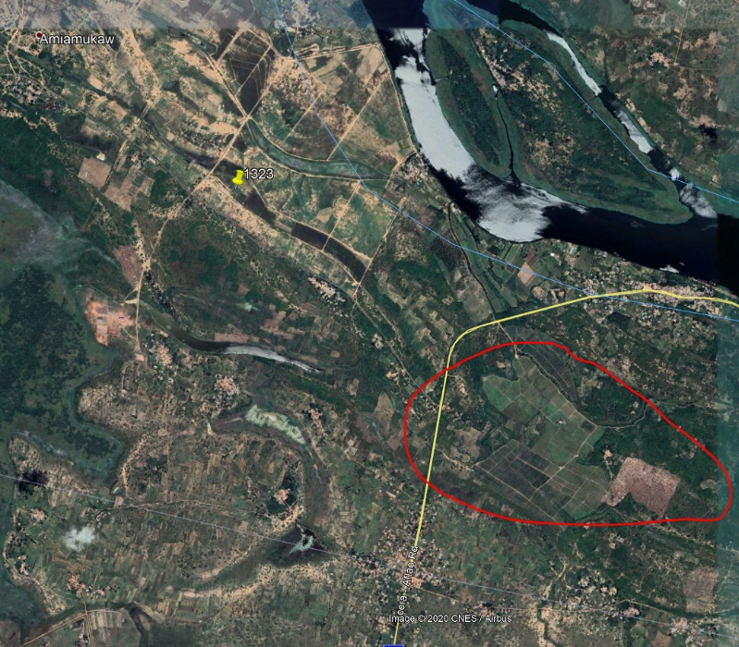

Deal 1346 – Oil Palm
Crop: Oil Palm
Timing:
Question: Oil palm over time (nucleus plus outgrowers)
Satellite imageries interpretation:

- Current status: The deal 1346 is a clear oil palm plantation. The polygon I draw is covering an area of about 6800 ha. That entire area is covered by oil palm at different development stages. In addition to that area that is clearly an industrial exploitation, I can spot some small patches of oil palm trees in the surroundings. What would you like to know about the outgrowers specifically ? The area it covers ?

- Development over time: I reviewed the existing thematic product GFC available at https://www.globalforestwatch.org/map and showing any tree cover loss in the period 2000-2019. It shows us that part of the forest was cleared already in 2002. But that product doesn’t tell us whether oil palm is planted after the clearing or not. I can spot oil palm trees from 2011, and expanding each year.

Deal 2241 – ScanFarm
Crop: various food crops and Timber (Corn (Maize), Rice, Soya Beans, Teak)
Timing:
Question: current status, current crops ?
Satellite imageries interpretation:

- Current status: The area seems active in both term of food crops and timber. The parcels are large parcels, proof of an industrial implementation. The central part of the polygon « Deal2241_ScanFarmPart1 » show a significant intra and inter annual variability. That part (800ha) is probably covered by annual food crops. On the other hand, the part on the top « Deal2241_ScanFarmPart2 » is not showing an important variability. The analysis of NDVI profiles is making me do the hypothesis that that part is covered by trees. That area covers about 600 ha.

- Development over time: Large scale parcels are visible since 2009. Large parcels are visible on VHR from 2010. This is confirmed by Landsat data where large clearings are visible from 2009. The area under exploitation is relatively stable since 2013.

Deal 3389 - Form Ghana
Crop: Trees
Timing:
Question: Current status of reforestation, intercropping by smallholders
Satellite imageries interpretation:

- Current status: In the area around the point shared, a big plantation is visible. I delimited a polygon «Deal3389_FormGhana » of about 3500 ha where I spotted trees in 2015, forming a geometrical shape. The area seems then to be expanding on the East.
- Development over time: The plantation is already visible in some of those areas in 2012.

Deal 3393 – Inga Farms
Crop: Tea, Coffee Plant, Food crops (unspecified), Oil Palm, Rubber tree, Sugar Cane?
Timing:
Question: Current status, exact locations?
Satellite imageries interpretation:

I don’t spot any big scale infrastructures. I am leaving it aside for the moment

Deal 3398 – Natural African Diesel
Crop: Biofuel
Timing:
Question: Development over time between conclusion and abandonment
Satellite imageries interpretation:

I don’t spot any big scale infrastructures even going back in the past. I am not sure where to look. I am leaving it aside for the moment

Deal 3399 – Africa Atlantic
Crop: Maize
Timing:
Question: Current status (nucleus plus outgrowers) of maize
Satellite imageries interpretation:

- Current status: my interpretation of a VHR from 2020 shows a status of abandonment of the infrastructure. But I am not 100% sure
- Development over time: VHR from 2013 shows a crop circle typical from an irrigated crop. Looking in the Landsat archive, that circle is visible from 2011. But the natural vegetation seems to be regrowing from 2016 (also from Sentinel-2 imageries).

Deal 3404 – Nicol-Miro
Crop: Timber
Timing:
Question: Current status of timber plantation, development over time
Satellite imageries interpretation:

- Current status: A timber plantation is visible. The trees are organised in geometrical parcels that making me guess it is a plantation. That area is illustrated by the polygon “ Deal3404_NicoMiro”.
- Development over time: VHR from 2012 and 2014 are showing a small timber plantation of about 100 ha. It seems the plantation started a bit before 2012 (trees are low). From the analysis of Sentinel-2 time series between 2016 and 2019, it seems that the area covered by trees increased each year. Is there other plantation or investments in the neighbourhood? We can investigate more about the area covered by trees if needed.

Deal 3761 – Mim cashews
Crop: cashew
Timing:
Question: Current status (cashew nuts) nucleus plus outgrowers
Satellite imageries interpretation:

- Current status: A industrial infrastructure is visible. I draw that area in the polygon “Deal3761_Mim”. The area I draw is of about 400ha, but the area cultivated could be bigger. There are many small patches of planted trees in the surrounding that could be outgrowers. I am also spotting some small patches of oil palm trees.
- Development over time: VHR from 2015, 2017 and 2019 are showing a clear industrial infrastructure with shrub vegetation that can be cashew nuts trees. New trees are planted, which makes me think that the investment is still active. Looking at other sources of data, clearings are visible from before 1990 (is that possible?)

Deal 3764 – Brazil agro
Crop:
Timing:
Question: Current status (rice), development over time
Satellite imageries interpretation:

- Current status: I see an active rice farm, expanding very rapidly. A VHR from 2020 allows me to delimited an area of 700 ha where rice is cultivated. That area is represented by the polygon “Deal3764_BrazilAgro”.
- Development over time: The infrastructure is visible from 2010 (the west part is the oldest one). The area is expanding a lot between the year 2013 and today.

Deal 3765 – Golden exotics
Crop: Pineapple, banana
Timing:
Question: Current status (pineapple, banana), development over time
Satellite imageries interpretation:

- Current status The deal 3765 show a very clear industrial infrastructure in all the type of imageries reviewed. I delineated the area visible on a VHR available for 2018 in the polygon “Deal3765_GoldenExotic”. The area is about 2400 ha.

- Development over time: There is a major increase of the infrastructure (about 500ha) towards the south between 2016 and 2018.

Deal 3768 – Global Agri
Crop: Rice
Timing:
Question: Current status (rice), development over time
Satellite imageries interpretation:

- Current status: A big infrastructure that is probably irrigated rice croplands is visible. I draw the polygon “Deal3768_GlobalAgri” of an area of 1400 ha of active cropland on a VHR from 2020.
- Development over time: A big infrastructure that is visible since 2014.

Deal 3770 – Volta Red Brewaniase
Crop: Oil Palm
Timing:
Question: Current status (oil palm), development over time
Satellite imageries interpretation:

- Current status: The latest VHR is from 2017, an oil palm plantation is visible. I draw the polygon “ Deal3770_VoltaRedBrewaniase” of 2600 ha.
- Development over time: The infrastructure is visible from 2010 and didn’t change much. Trees have been growing.

Deal 3773 – Norpalm
Crop: Oil Palm
Timing:
Question: Current status (oil palm), development over time
Satellite imageries interpretation:

- Current status: A oil palm plantation is visible around the point 3773. I draw the polygon “Deal 3773_Norpalm” on a VHR of 2018. It covers an area of about 5000 ha.
- Development over time: Infrastructure visible since 2011

Deal 3915 – Formako
Crop: cacao, maize, pineapple
Timing:
Question: Current status (cacao, maize, pineapple), development over time
Satellite imageries interpretation:

- Current status: The crop that is visible in the recent imageries looks like tree or shrub that have been planted in 2017. I draw the outline of that recent crop visible on a VHR from 2020. It covers an area of about 130 ha.
- Development over time: The surroundings of the deal 3915 have been changing over time. Large infrastructures are visible already from 2011. But the type of crop has evolved over time. I don’t know what crop was cultivated before but it changed between 2016 and 2017. Is it possible that the pineapples and maize have been replaced by another crop?

Before 2016

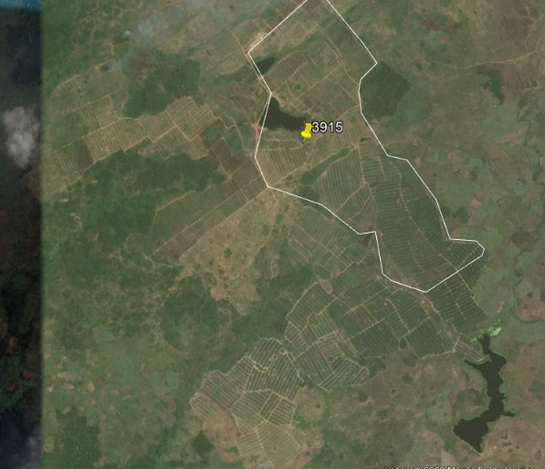

In 2020
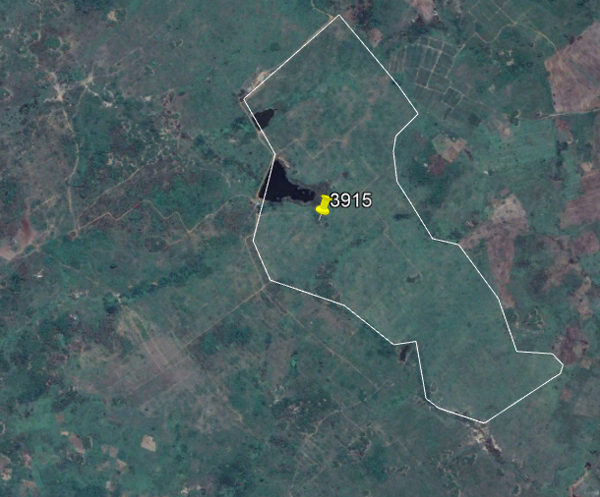

Deal 4341 – Hulstein (Abraham farms)
Crop: corn, rice
Timing:
Question: Current status (corn, rice), development over time
Satellite imageries interpretation:

- Current status: I see two circles that makes me think of irrigation infrastructure. But the parcels cultivated are small, doesn’t seem big industrial activities.
- Development over time: the two circles are constructed between 2013 and 2014. And some pools (rice?) are constructed from 2013 in the north of the village.

Deal 4583 – Gold coast fruit
Crop: mango, papaya, pineapple
Timing:
Question: Current status (mango, papaya, pineapple), development over time
Satellite imageries interpretation:

- Current status: Large parcels are visible around the point 4583. The whole area seems to be intensively cultivated, difficult to see the limits of the deal 4583.
- Development over time: need to know better which part to look at. The whole area is very active in term of industrial agriculture since 2010 for sure. I need to check other imageries to go back more in time.

Deal 4730 – Volta Red Pepesu
Crop: Oil Palm
Timing:
Question: Current status (oil palm), development over time
Satellite imageries interpretation:

- Current status: A small oil palm plantation is visible around the deal 4730. I delineated an area of 45 ha on a VHR of 2017.
- Development over time: The area didn’t change much in the recent years.

Deal 4940 – Babator
Crop: crops
Timing:
Question: Current status (crops), development over time
Satellite imageries interpretation:

No clear industrial infrastructure

Deal 5316 – Tamale Integrated Fruit Company
Crop: Mango
Timing:
Question: Current status (Mango), development over time
Satellite imageries interpretation:
- Current status: Mango plantation is active. From a VHR of 2020, I delineated an area of 200 ha.
- Development over time: A big industrial crop pattern is visible since 2011 and is probably implemented already before.

Deal 6057 – African Plantations for Sustainable Development (APSD)
Crop: Trees
Timing:
Question: Current status of timber plantation, development over time
Satellite imageries interpretation:
- Current status: a tree plantation is well visible. I mapped an area of about 11500ha on a VHR of 2016. The trees visible are at different stages of growth.
- Development over time: the plantation visible since 2013. I can observe an increase in the NDVI (indicator of the presence of vegetation) at the same time.

Deal 6742 – Twifo oil plantations
Crop: Oil Palm
Timing:
Question: Current status (oil palm), development over time
Satellite imageries interpretation:
- Current status: a oil palm plantation is well visible. I mapped an area of about 4600 ha on a VHR of 2020. There is another patch of oil palm on the other side of the road – is it part of it?
- Development over time: the plantation is visible since 2011. I have to check on other imageries when it first started.

Some recommendations for the field campaign

To discuss

